Guide to Setting Up the Database in MongoDB
Objective:
The objective of this guide is to provide clear and concise instructions for setting up the TheMovieDB database in MongoDB, ensuring proper database creation and configuration for managing movies records.

Step 1: Download MongoDB

- Go to the official MongoDB download page.
- Choose the latest version of MongoDB Community Edition.
- Under "Platform," select Windows.
- For "Package," choose MSI (Windows Installer).
- Click the Download button.
Step 2: Install MongoDB

- Once the .msi file is downloaded, double-click it to start the installation.
- Select Complete for the installation type.
- After the installation is completed, click Finish.

Step 3: Configure MongoDB

If you want MongoDB to store data in a different location, you can edit the mongod.cfg file to specify the dbPath.
Go to the directory where MongoDB was installed (usually, C:\Program Files\MongoDB\Server\<version>\bin).

Step 4: Access MongoDB via MongoDB Compass

Run MongoDB Compass and connect to the default MongoDB server (usually mongodb://localhost:27017).

Step 5: Creation of the database and collections

Click to create the database and, by default, specify a collection as shown in these two images.

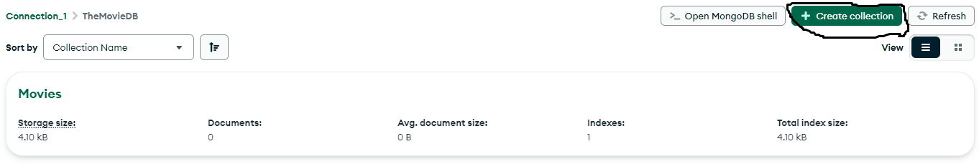
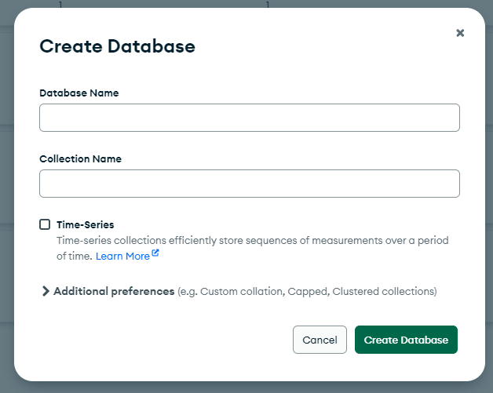

Once the database is created, then you can create other collections as shown in these two images.
